Container Instance

Contents

1. Introduction 3
2. Workflow diagram to deploy the stack 3
3. Create stack for Container instance 4
4. Plan the Job 7
5. Apply the Job 8
6. Destroy the stack 11

Introduction

Oracle Cloud Infrastructure (OCI) Container Instances is a serverless compute service that enables user to instantly run containers without managing any servers. This resource provides the Container Instance resource in Oracle Cloud Infrastructure Container Instances service.
Using Container Instances, easily launch one or more containers with flexibility to specify compute shape, resource allocation, networking, and other optional configurations. Container Instances run on a dedicated environment with strong isolation for improved security.

Workflow diagram to deploy the stack

Below diagram shows how the Terraform Artifact are applied in the OCI. While creating a ORM stack, using terraform deliverables Init, Plan and Apply is the flow to provision the resource in the OCI. We can have the deliverables in any of below.

- Git Lab/GitHub Repo
- Bit bucket
- Can be in folder/.zip in the local disk
- Object Storage Bucket
- Can be in compartment
- Oracle provided Template


Create stack for Container instance

Go to OCI Console Developer Services Resource Manager Stacks select the compartment Create Stack

My Configuration Folder Browse Select the “Container_instance” folder that contains the terraform Upload

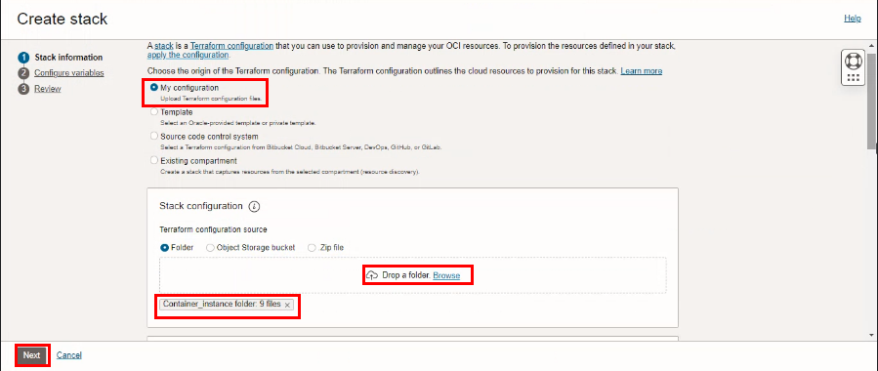

Select the parameters as per the below screen,
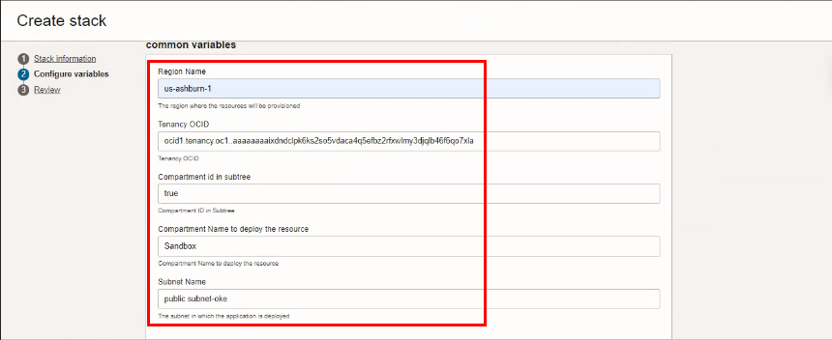

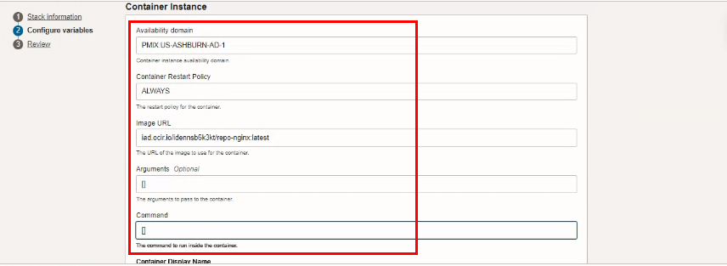
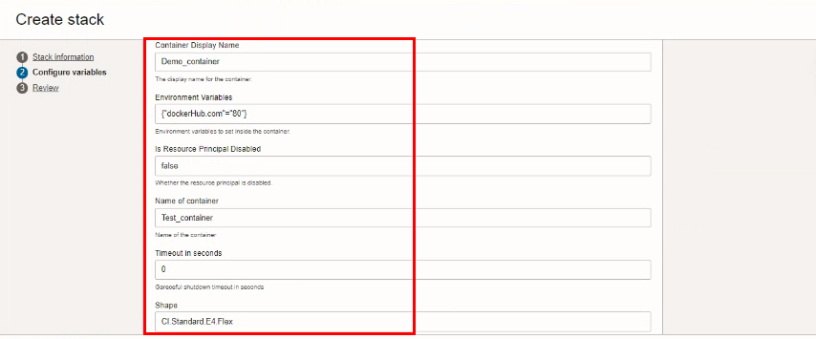

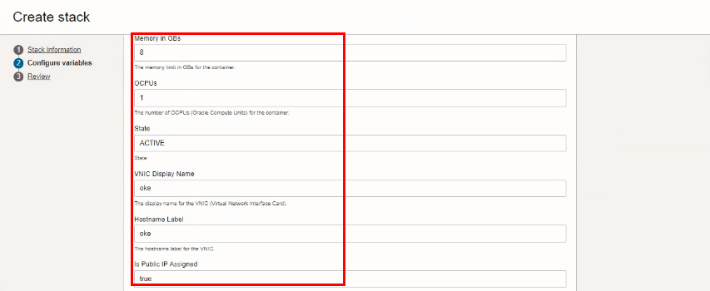

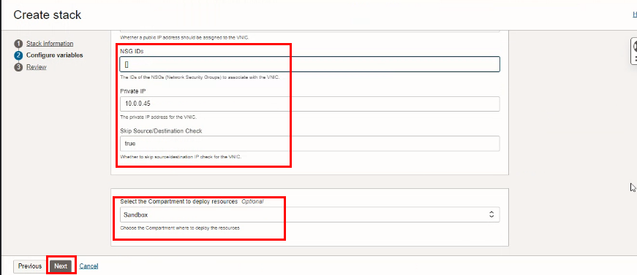

Click “NEXT”

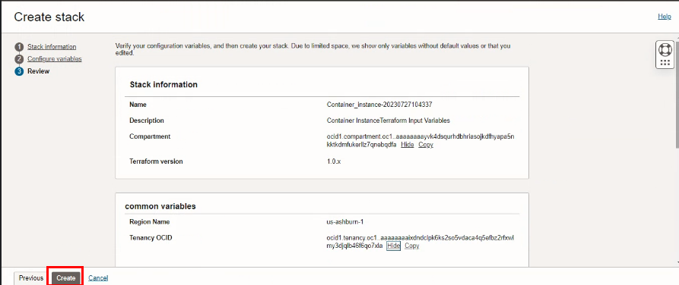
Click “CREATE”

Plan the Job
Click the “Plan”
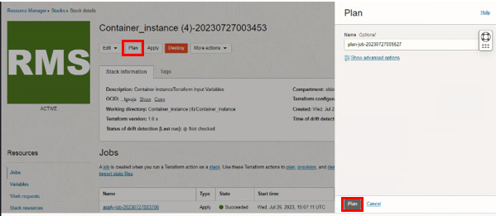

Verify the Plan is successful.
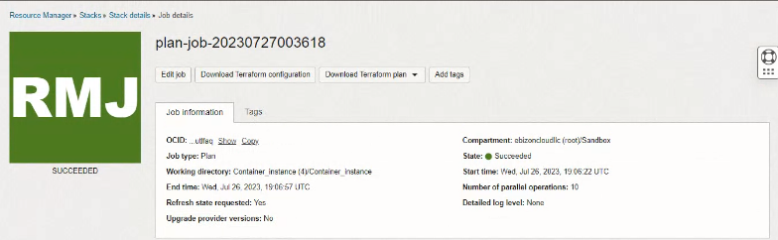

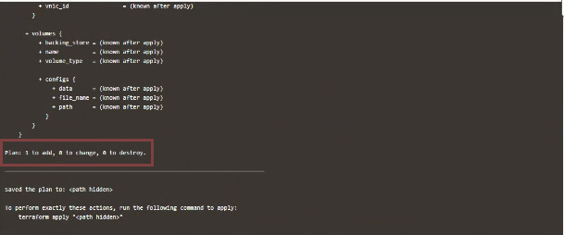

- Apply the Job

Once the “plan” is success, now click “Apply”
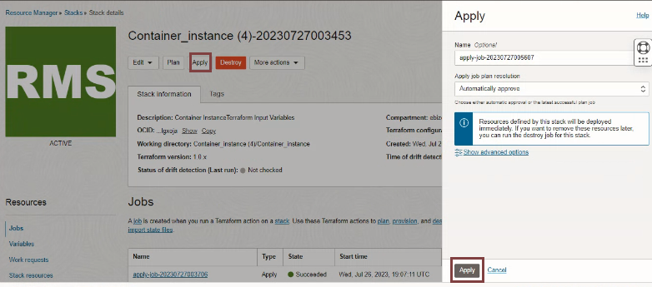

Verify the Apply is successful.
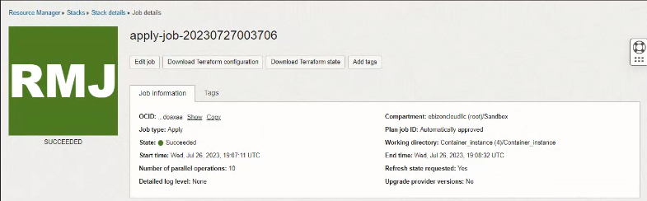

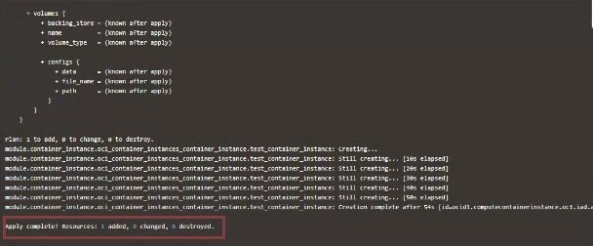

- Pre requisite

- Create IAM policies for container instance

- Create a Repository (Public or Private)

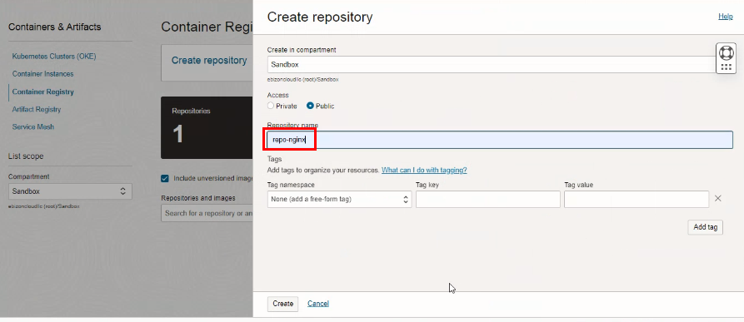

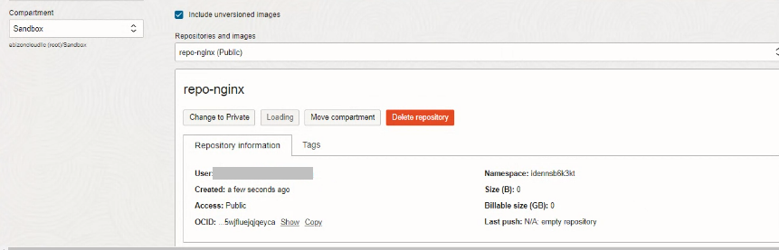

- To Pull and Push Nginx image, Run below commands in OCI cloud shell.
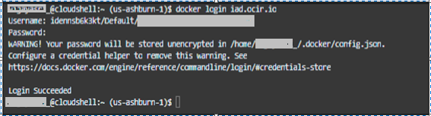
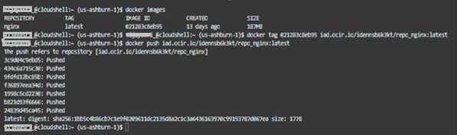

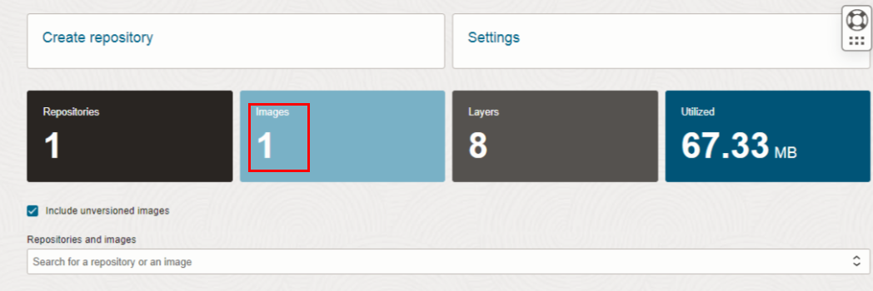

Destroy the stack

Create a destroy job in Resource Manager to release resources associated with a stack and clean up the tenancy. Once destroyed data cannot be recovered from resources.
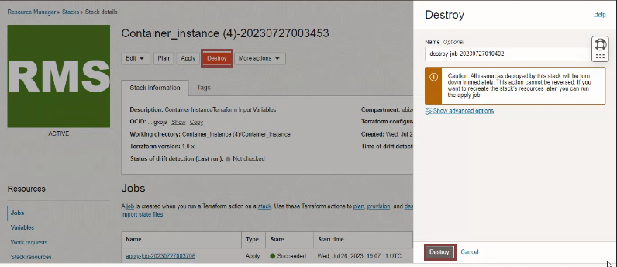

#END#

